THE SEA BATTLE

DOWNLOAD AND INSTALLATION

Find the game under the link: <https://github.com/Andromeda6688/SeaBattle-WPF>.

Simply copy the content of the folder “SeaBattle-WPF/SeaBattle1/bin/Release/” to your local computer. Start file “SeaBattle1.exe“ to play.

THE INTERFACE

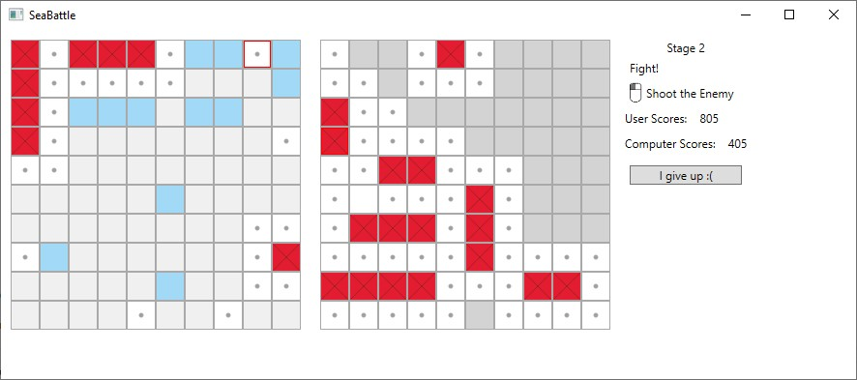

3

2

1

The are three areas:

1 – the playing field of user;

2 – the playing field of the computer;

3 – informational panel.

The playing fields consist of cells (10x10). The state of cell is indicated as it is shown:

|  |  |
| --- | --- |
|  | empty cell |
|  | invisible cell of the playing field of the computer |
|  | healthy cell |
|  | wounded cell |
|  | dead cell |
|  | shooted cell |

STAGE 1. ARRANGING THE BOATS

User can fill his playing field using mouse. To draw a cell of a boat left button should be pressed. If a mistake happened, the wrong cell can be removed by clicking the right mouse button.

The arrangement meets the following conditions:

* The collection of boats should consist of a certain number of boats as it shown on the picture:

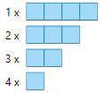

* The boats can have horizontal or vertical orientation, but not diagonal. In addition, they cannot bend.
* Between two boats, there should be no less than one empty cell. Diagonal touch is also not allowed.

When the boats are arranged, press the button “Check and start” on the informational panel. If there is a mistake, please correct the arrangement and press the button one more time. If the boats are arranged correctly, the next stage begins.

STAGE 2. GAME ON

Use left mouse button to shoot a cell on the playing field of the computer. If the shoot was successful, repeat. The computer shoots automatically after each shoot of the user.

Player earns some score, which amount depends on the type of the shooted boat:

|  |  |  |
| --- | --- | --- |
| Battlecruiser |  | 15 |
| Cruiser | 30 |
| Destroyer | 60 |
| Torpedo boat | 150 |

Each unsuccessful shoot is punished with five scores.

The player, who first killed all boats of enemy, wins.

STAGE 3. RESULTS

After the game finished, the leadership window is shown. If the result of player is in Top-10, he will be offered to save his name in the table of leaders.

